Linked containers lab guide and connecting webapp and mysql db with mediawiki

First create a container with web app

# docker run -itd -p 5008:80 --name web-host ubuntu:14.04 /bin/bash

# docker exec -it web-host /bin/bash

**Step 1 : Install pre-requisites**

# apt-get update

# apt-get install libapache2-mod-php5 php5 php5-common php5-curl php5-dev php5-gd php5-idn php-pear php5-imagick php5-mcrypt php5-mysql php5-ps php5-pspell php5-recode php5-xsl mysql-client libmysqlclient15-dev apache2 apache2-doc apache2-mpm-prefork apache2-utils libexpat1 ssl-cert wget vim -y

**Step 2 : Go to /var/www directory**

# cd /var/www

**Step 3 : Download media-wiki software package**

# wget <http://releases.wikimedia.org/mediawiki/1.24/mediawiki-1.24.1.tar.gz>

**Step 4 : un tar the software packages**

tar xvf [mediawiki-1.24.1.tar.gz](http://releases.wikimedia.org/mediawiki/1.24/mediawiki-1.24.1.tar.gz)

**Step 5 : Goto the apache2/sites-enabled directory**

vim /etc/apache2/sites-enabled/000-default.conf

**Note : search for document root and add the path of your webapp folder i.e.**

/var/www/mediawiki-1.24.1

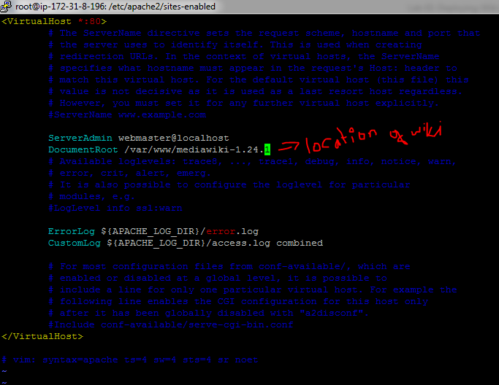

**Step 6 : Restart apache2 service**

service apache2 restart

**Note : validate with Public IP of your host on web browser if site is up**

**IPaddress ex 18.221.188.111:5000**

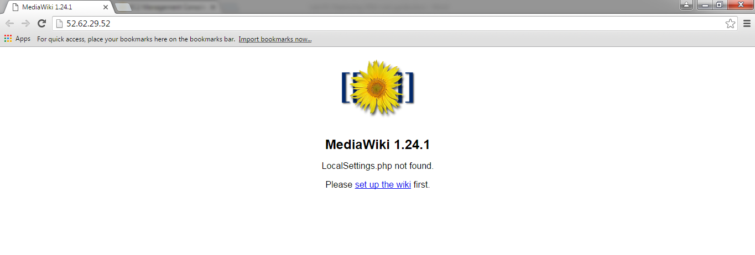

**Now we will start with Mysql db Host**

**Create the second container linking with the Web – host container**

# docker run -itd -p 5009:3306 --name db-host ubuntu:14.04 /bin/bash

docker exec –it db-host /bin/bash

**Step 1 : Install pre-requisites**

# apt-get update

# apt-get install mysql-server vim -y

**Step 2 : Edit the my.cnf file and add the following lines**

# vim /etc/mysql/my.cnf

[mysqld]

default-storage-engine = innodb

innodb_file_per_table = on

max_connections = 4096

collation-server = utf8_general_ci

character-set-server = utf8

bind-address = 0.0.0.0

**Step 3 : Restart mysql service**

# service mysql restart

**Step 4 : Login to mysql**

# mysql -u root -p

**Step 5 : Create database customer and grant privileges for cloudenabled user**

mysql> create database customer;

mysql> grant all on customer. * to 'cloudenabled'@'%' identified by 'root1234';

mysql> exit;

**Step 6: Goto web browser and visit you’re the public IP your wiki instance > click on setup wiki first**

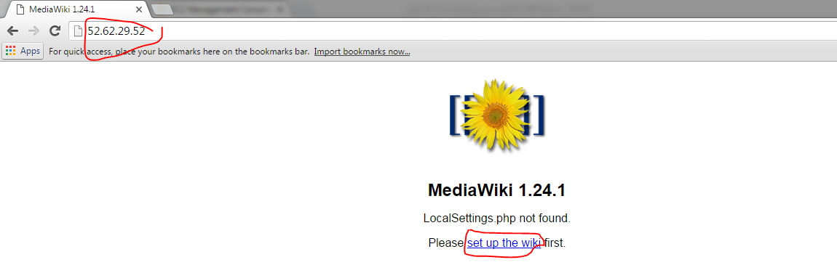

**Step 7: leave the defaults and click Continue**

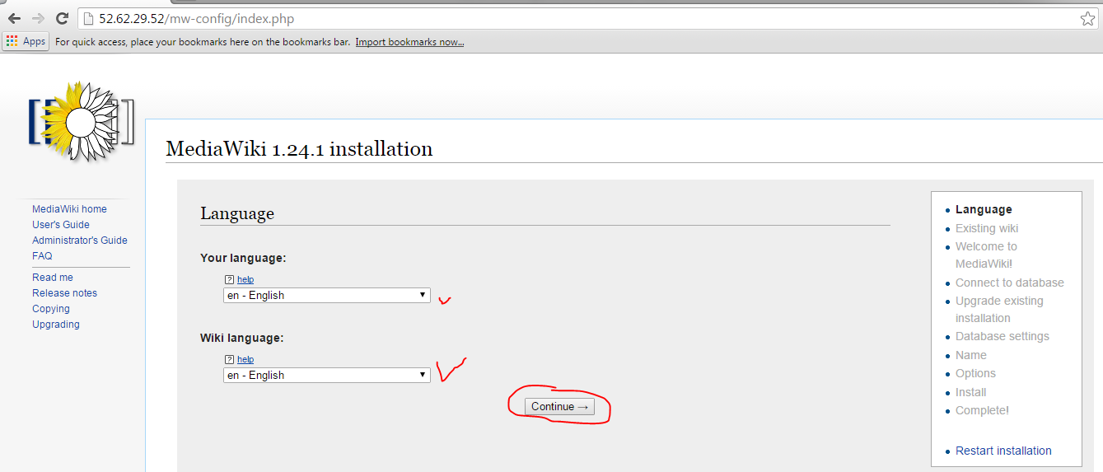

**Step 8 : click Continue**

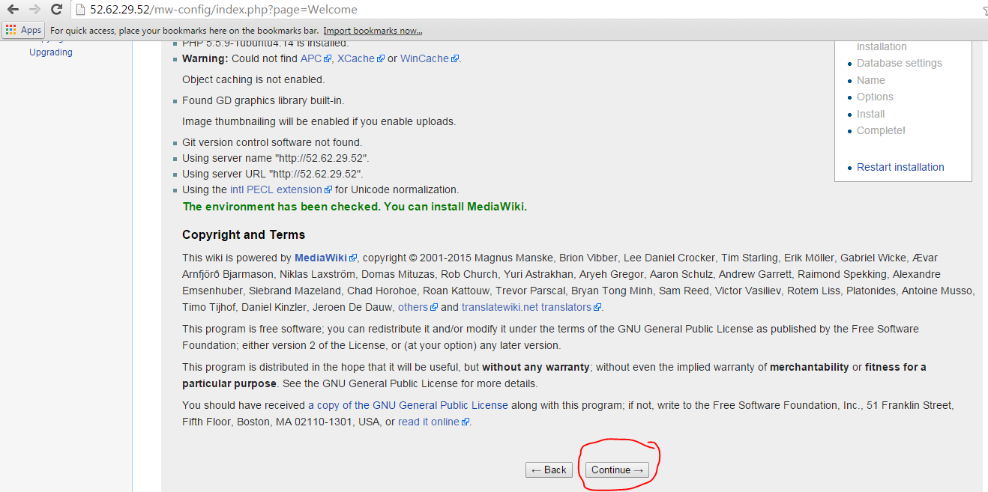

**Step 9 : Proceed with details of your RDS as below**

**DB container IP**

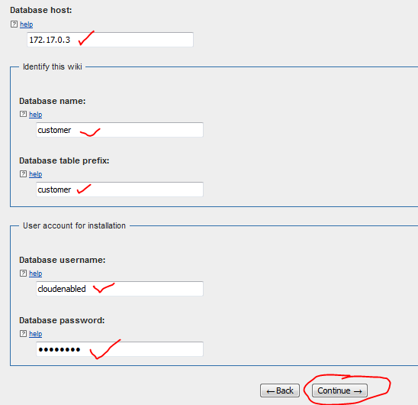

**Step 10 : Go with defaults and click continue**

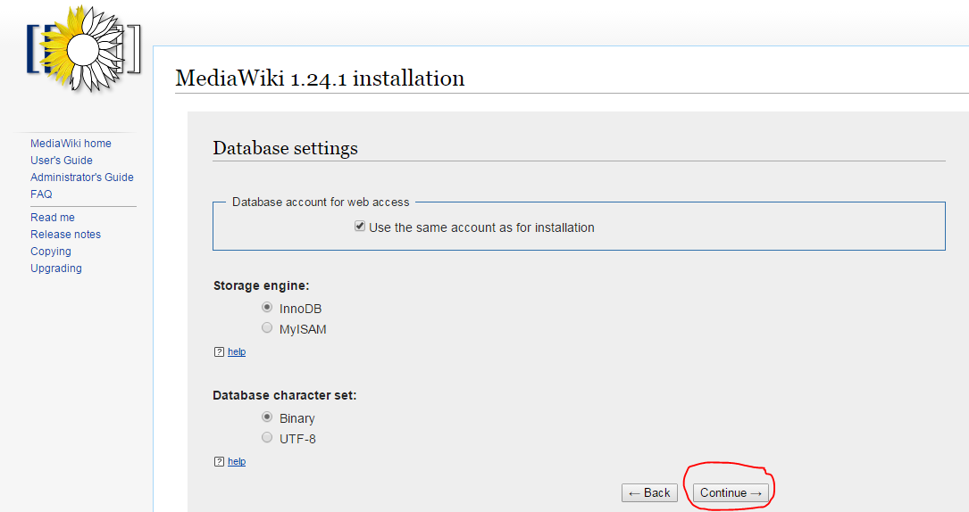

**Step 11 : the below are wiki admin setting for login and your desired wiki name**

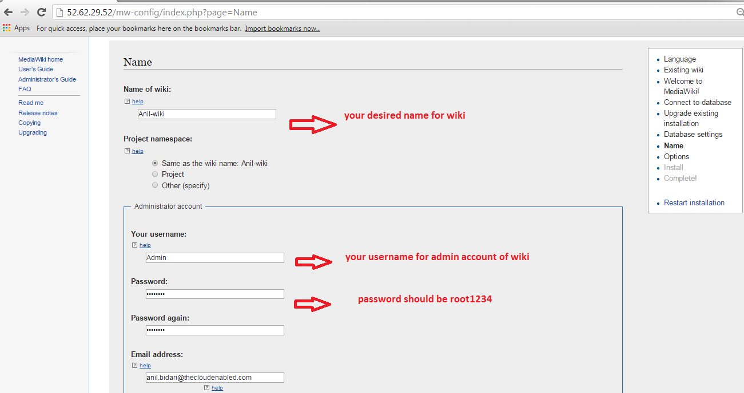

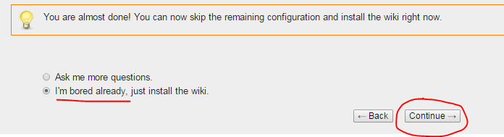

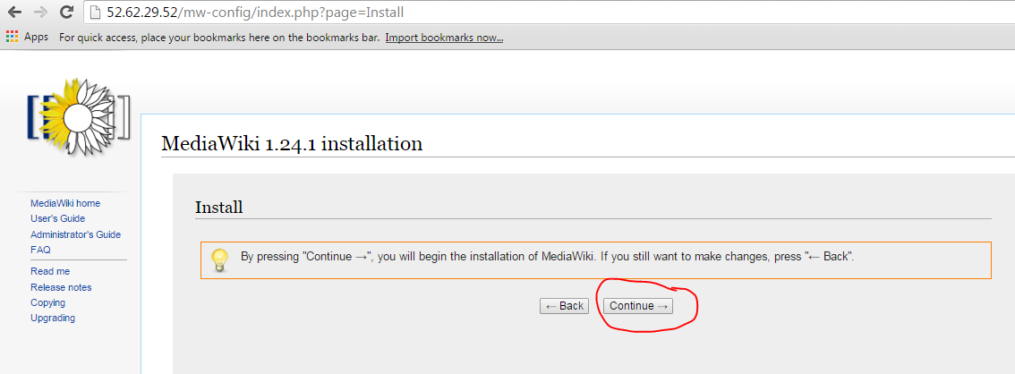

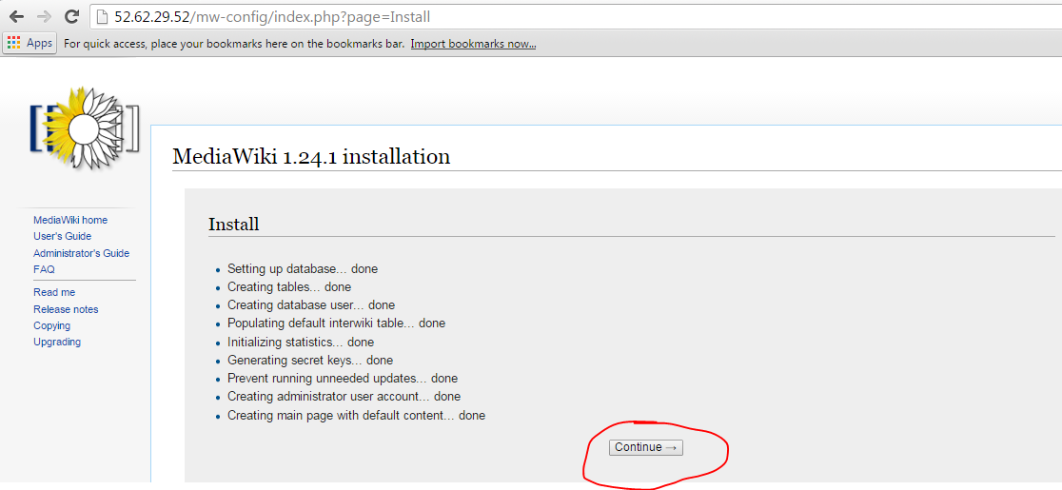

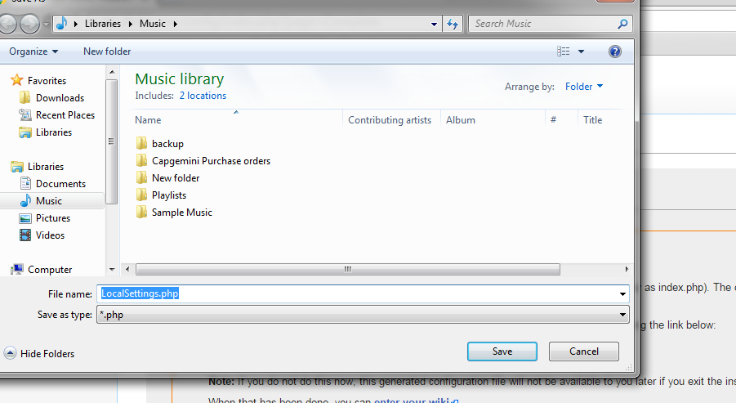

Login to web-host and copy local seetings file

docker exec -it web-host /bin/bash

cd /var/www/mediawiki-1.24.1

vi LocalSettings.php

service apache2 restart

exit

Login to your ip:5000